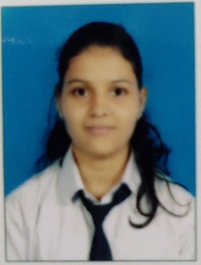

Name:-Prajakta Sanjay Mohide

**Permanent Address:**

Ganpati Galli, old Jalna,

Tq. Jalna,

Dist. Jalna.

Pin: 431213

**E-mail: prajaktamohide1504@gmail.com**

|  |  |  |  |
| --- | --- | --- | --- |
| **Examination** | **Institute** | **Year of Passing** | **Percentage** |
| B. Tech | M G M’s Jawaharlal Nehru Engineering college, Aurangabad | 2023 | 90.34  (5thsemester) |
| Diploma | Government Polytechnic Ambad | 2019 | 84.53 |
| S.S.C | Saraswati Bhuvan High school,  Jalna | 2016 | 78.80 |

**Contact no.:** +91 9309126427

# OBJECTIVE

To pursue a highly rewarding career in challenging and healthy work environment where I can utilize my skills and knowledge efficiently for organizational growth

.

# EDUCATIONAL QUALIFICATION

# TECHNICAL SKILLS

1. C Programming
2. Python Programming
3. Assembly Language Programming

# PROJECTS

1. Finger print voting machine using Arduino.
2. Obstacles Detector using Arduino.
3. Distance Measurement using ultrasonic sensor.

# CURRICULAR ACTIVITIES

1. Seminar on Raspberry Pi-3.
2. Poster presentation on Mobile Technologies.
3. Attended Workshop held at IGTR Aurangabad.

# PERSONAL SKILLS

1. Presentation Skill
2. Good In Communication
3. Leadership
4. Disciplined behavior

# PERSONAL DETAILS

**Name :** Mrs. Prajakta Sanjay Mohide

**Date of Birth :** 15th April 2000

**Languages Known :** English, Hindi, Sanskrit and Marathi.

**Hobbies :** listening music, painting.

I hereby declare that the information furnished above is true to the best of my knowledge.

**Place:** Jalna

**Date:**   **( Prajakta Sanjay Mohide)**